**1. which of the following device is used to carry user files?**  
A. Floppy Disk              B. Hard Disk  
C. RAM                            D. CDROM  
Answer: A

**2. Which device is used to backup the data?**  
A. Floppy Disk               B. Tape  
C. Network Drive.        D. All of the above  
Answer: D

**5. Which is the best units of data an external storage device?**  
A. Bits                                             B. Bytes  
C. Hertz                                         D. Clock cycles  
Answer: B

**7. Which of the following is a read only memory storage device?**  
A. Floppy Disk                                             B. CDROM  
C. Hard Disk                                                 D. None of these  
Answer: B

**13. A Pixel is**  
A. A computer program that draws picture  
B. A picture stored in secondary memory  
C. The smallest resolvable part of a picture  
D. None of these  
Answer: C

**14. Which device is used as a standard pointing device in a Graphical User Environment?**  
A. Keyboard B. Mouse  
C. Joystick D. Track ball  
Answer: B

**16. Which no. system is often follow in a typical 32 bits computer ?**  
A. Binary                                                            B. Decimal  
C. Hexadecimal                                               D. Octal  
Answer: A

**17. Which of the following is not an output device?**  
A. Scanner                                        B. Printer  
C. Flat Screen                                  D. Touch Screen  
Answer: D

**18. Which is the following devices has  limitation as we can only stored info. to it but cannot delete or modify it?**  
A. Floppy Disk                                 B. Hard Disk  
C. Tape Drive                                    D. CDROM  
Answer: D

**19. Which technology is used in Compact disks?**  
A. Mechanical                                  B. Electrical  
C. Electro Magnetic                       D. Laser  
Answer: D

**20. Which is the following storage device can store maximum no. of data?**  
A. Floppy Disk                               B. Hard Disk  
C. Compact Disk                           D. Magneto Optic Disk  
Answer: B

**24.Who build the first Mechanical Calculator**  
A. Joseph Marie Jacquard                           B. John Mauchly  
C. Blaise Pascal                                                 D. Howard Aiken  
Answer: C

**37. he BIOS is the abbreviation of ………**  
A. Basic Input Output System                  B. Best Input Output System  
C. Basic Input Output Symbol                  D. Base Input Output System  
Answer: A

**38. What do u say a single point on a computer screen**  
A. Cell                                        B. Element  
C. Pixel                                      D. Bit  
Answer: C

**Storage:**

A computer is a binary device and it can store information in the form of zeros or ones. Zero or one are knows as bits and 8 unit of bits makes one byte. Memory of a computer can store bits for later use. Measurement scale of bytes are as follow

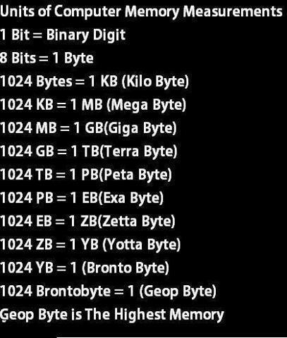

**Types of Storage:**

Volatile storage is a type of storage that preserve information while it is supplied with electricity.

Non-Volatile Storage is a type of storage that can preserve information even when no electricity is provided to it.

**History of Storage (Non-Volatile)**

Punch Cards:   
Big Physical cards used to store information by maintaining holes for zeros and bumps for ones. It can store 80 bytes.

Floppy Disk:  
Floppy disk is a plastic magnetic disk used to store information. Its storage capacity is 1.44 Megabyte

Hard Disk:  
Hard disk is a metal magnetic disk used to store information. Its storage capacity is 500 Gigabyte.

CDROM:  
 Compact Disk Read Only Memory (CDROM) is a plastic mirror disk that store information using laser reflection.   
 Its storage capacity is 680 Megabyte.

USB storage:  
 Universal Serial Bus Storage is an Electronic Programmable (EP) memory that can store 32 Gigabyte of   
 information